**Online Retail Sales -Report**

# Abstract

This project presents an interactive sales dashboard system for an online retail platform using Python and MySQL. The dashboard provides useful business insights such as top-performing customers, monthly sales trends, and city-wise product performance. A location-based filtering system ensures focused analytics, starting with Bhubaneswar as the default city.

# Introduction

The goal of the Online Retail Sales Dashboard is to enable an interactive experience for business users to view, analyze, and report on customer and sales performance. The system provides analytical insights directly from a structured MySQL database, leveraging Python for its frontend interface and visualization.

# Tools Used

- Python 3.12  
- MySQL  
- SQLAlchemy  
- Faker  
- Pandas  
- Matplotlib  
- Seaborn

# Implementation Steps

1. Created the schema in MySQL and generated sample data using Faker.  
2. Established SQLAlchemy connection for Python-to-MySQL communication.  
3. Developed a menu-driven dashboard with 4 main reports:  
 - Top 10 Customers by Spending  
 - Monthly Sales Trend  
 - Product-wise Sales Distribution  
 - Top 10 Cities by Sales  
4. Integrated location filter (default: Bhubaneswar).  
5. Visualized reports using Matplotlib and Seaborn.

# Sample Outputs

Each report generates a plot or table that gives users visual and tabular representation of insights. Example charts include line graphs for trends and bar graphs for top cities or customers.

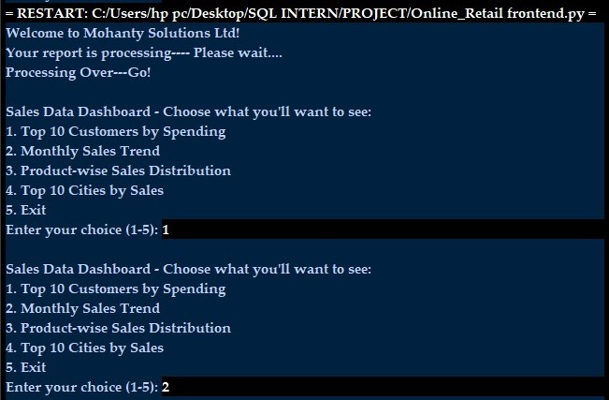

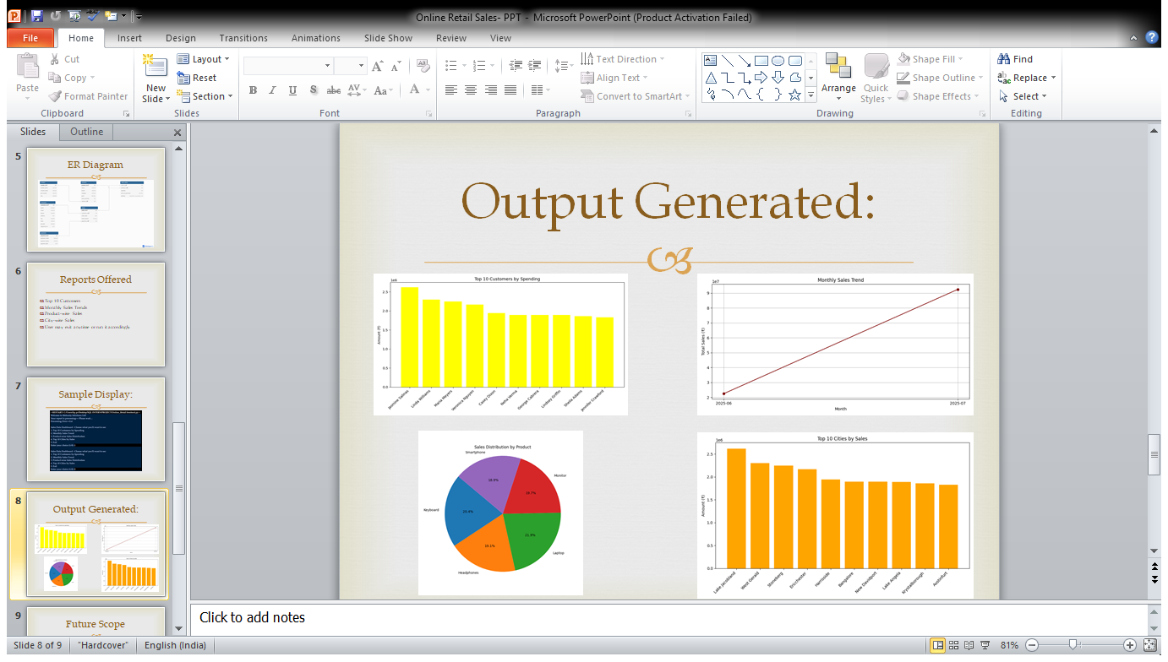

# Conclusion

The Online Retail Sales Dashboard successfully meets its objectives by delivering key business insights interactively. It uses a reliable backend, flexible frontend, and customizable filters making it practical for real-world analytics use-cases.